COYOTE
Kyle Bauer, Rikki Adolfsen, and
Gabby Ostert
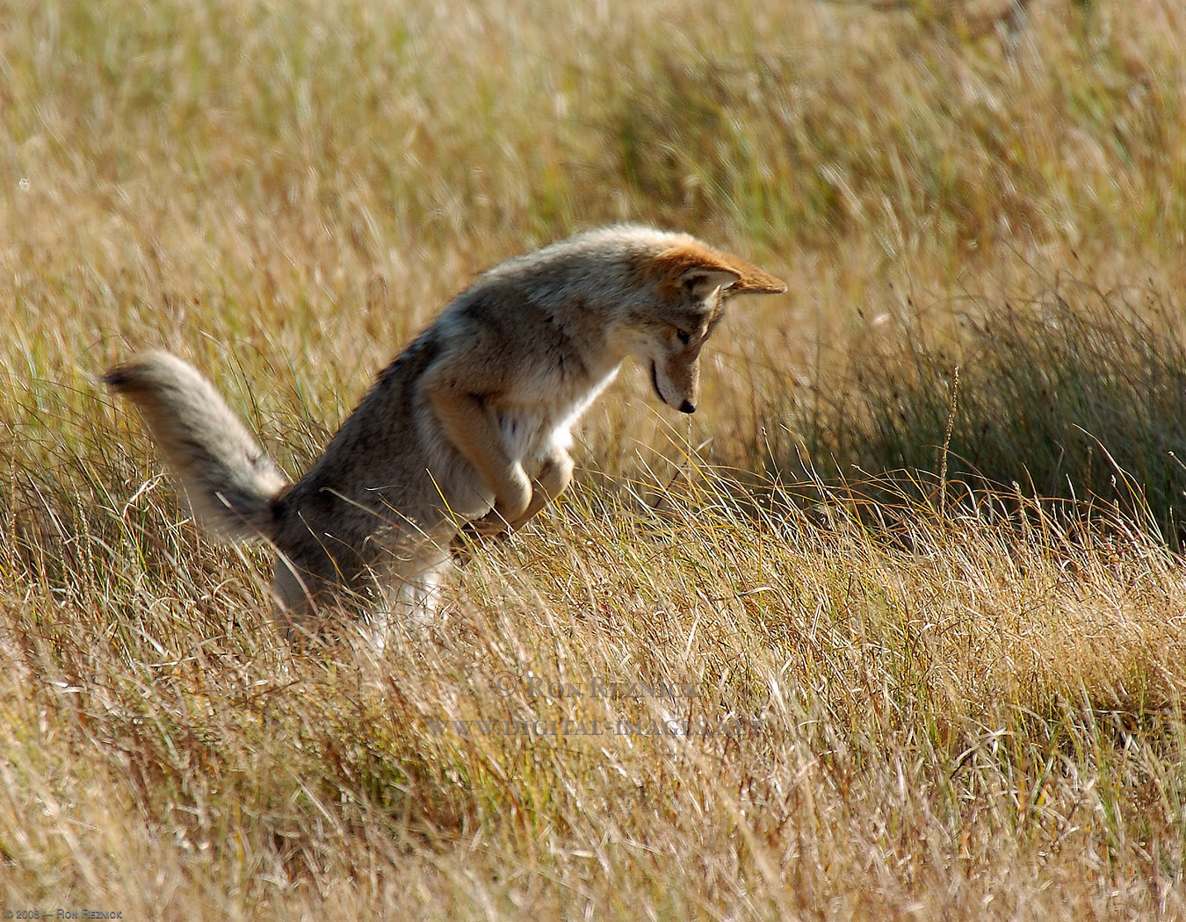
Biology 6th Period

5/10/13
Coyote

A. Common/Scientific Name:
- Canas Latrans – Barking Dog

B. Range:
- On the rise throughout Iowa
- Native to Iowa
- Definite count hard to get due to their secretive nature

C. Habitat:
- Farmlands
- Plains & fields
- Woodlands & Grasslands
- Timbers
- Prairies & Meadows

D. Feeding:
- Carnivores
- Deer, squirrel, pocket gophers, beavers, elk, rabbits, mice, ground nesting birds
- Insects, fruit, berries,
- Scavenge large kills of other animals
- Hunt both day & night

E. Instinctive Behavior:
- Shy and sneaky
- Friendly yet brazen
- Keen hunters
- Great foraging skills
- Very good swimmers
- Breeding peaks in late February or early March
- Springtime females den & birth 3-4 pups
- Both parents feed & protect pups
- Pups are blind and helpless at birth
- Pups able to hunt following fall of their birth
- Strong sense of smell & keen vision
- Fall & winter form packs for effective hunting

F. Extra Facts:
- Smaller than wolves
- Distinctive call – raucous canine chorus at night
- Can run up to 40 miles per hour
- Average life span 4 years
- Cleverly adapt to American landscape changes
- Usually 20 – 50 pounds
- Heady & body 32-37 in, tail 16 in
- Population at all time high currently
- Members of one pack rarely into territory of another
- Mark areas with urine, feces or gland secretions

Log
4/15 We chose the coyote as our topic
4/19 Kyle and Rikki got information
4/19 Gabby made title page
4/25 All had the idea of an interview
4/29 Gabby And Rikki found costumes
5/1 All made script
5/1 All finished script
5/6 Filmed at Rikki’s house
5/7 Rikki and Gabby edit and finish video
5/7 Kyle finished log and outline
5/10 Project due

