Fish Identification Poster Project

Throughout this unit you will be examining Iowa waterways with regards to lakes & rivers, water quality, watersheds, and water treatment. In addition to the ecology of the waterways, you will learn to identify major fish families of the state of Iowa. To help identify these fish, you will create a poster that illustrates identification clues about each fish family. The poster is due in two weeks. The following criteria must be fulfilled :

1. Choose 5 of the following fish families to research and identify representatives.

- Bowfin Family
- Catfish Family
- Freshwater Drum Family
- Gar Family
- Gizzard Shad Family
- Minnow Family
- Paddlefish Family
- Perch Family
- Pike Family
- Stickleback Family*
- Sturgeon Family
- Suckers Family
- Sunfish Family
- Temperate Bass Family
- Trout Family

2. Create the following poster pages :

Title

- Include the word, “Iowa”
- Type out title

Fish Family #1

- Identify 5 characteristics for identification of the fish family
- Include three examples (labeled) and three pictures from the fish family

Fish Family #2

- Identify 5 characteristics for identification of the fish family
- Include three examples (labeled) and three pictures from the fish family

Fish Family #3

- Identify 5 characteristics for identification of the fish family
- Include three examples (labeled) and three pictures from the fish family

Fish Family #4

- Identify 5 characteristics for identification of the fish family
- Include three examples (labeled) and three pictures from the fish family

Fish Family #5

- Identify 5 characteristics for identification of the fish family
- Include three examples (labeled) and three pictures from the fish family

Appearance

: Do not use paragraphs
: Fill up the page (avoid “dead space”)
: Put a heading on each panel (Fish Family)
: Use the examples on the back as a guide

GRADING RUBRIC

EX = Exceeding MT = Meeting DV = Developing BG = Beginning

- Typed or Stenciled Title - Typed or Stenciled Title - Handwritten Title - No Title
- All Fish Family Titles Present - All Fish Family Titles Present - All Fish Family Titles Present - Missing Fish Family Titles
- 25 Characteristics Present - 25 Characteristics Present - 18 or Less Characteristics - 12 or Less Characteristics
- 15 Pictures Present - 15 Pictures Present - 10 or Less Pictures Present - 5 or Less Pictures Present
- Pictures Completely Labeled - Pictures Completely Labeled - 10 or Less Pictures Not Labeled - Pictures Not Labeled
- Accurate Identification - Accurate Identification - Accurate Identification - Inaccurate Information
- Orderly Display Of Families - Orderly Display Of Families - Orderly Display Of Families - Disorganized Display
- Color Accent Borders Present - Color Accent Borders Present - Minimal Color Added - Plain Background Only
- Detailed & Neat Appearance - Detailed & Neat Appearance - Messy Appearance - Messy Appearance
____________________________________ - 1 Element Missing From EX ____________________________________ _______________________________

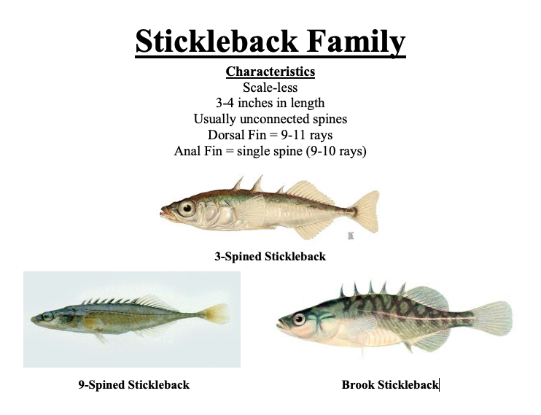

FISHES NATIVE TO IOWA

