IPDE Process

Examine each of the situations and then apply the IPDE Process.

1. Identify two factors that may need to be addressed.
2. Predict two possible scenarios or problems that may arise.
3. Decide on two possible courses of action that may be taken.
4. How would execute in this situation?

1. You are trying to leave this parking lot.

(I)dentify : 1. _________________________________________________________

2. _________________________________________________________

(P)redict : 1. _________________________________________________________

2. _________________________________________________________

(D)ecide : 1. _________________________________________________________

2. _________________________________________________________

(E)xecute : 1. _________________________________________________________

2. You are the car in blue attempting a left turn.

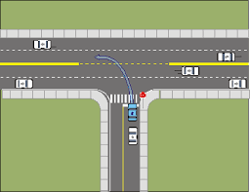

(I)dentify : 1. _________________________________________________________

2. _________________________________________________________

(P)redict : 1. _________________________________________________________

2. _________________________________________________________

(D)ecide : 1. _________________________________________________________

2. _________________________________________________________

(E)xecute : 1. _________________________________________________________

3. You are approaching this intersection.

(I)dentify : 1. _________________________________________________________

2. _________________________________________________________

(P)redict : 1. _________________________________________________________

2. _________________________________________________________

(D)ecide : 1. _________________________________________________________

2. _________________________________________________________

(E)xecute : 1. _________________________________________________________

4. You are the green car behind the semi-trailer truck and in front of the blue car.

(I)dentify : 1. _________________________________________________________

2. _________________________________________________________

(P)redict : 1. _________________________________________________________

2. _________________________________________________________

(D)ecide : 1. _________________________________________________________

2. _________________________________________________________

(E)xecute : 1. _________________________________________________________

5. You are driving the red car.

(I)dentify : 1. _________________________________________________________

2. _________________________________________________________

(P)redict : 1. _________________________________________________________

2. _________________________________________________________

(D)ecide : 1. _________________________________________________________

2. _________________________________________________________

(E)xecute : 1. _________________________________________________________

6. You are approaching this situation with your car.

(I)dentify : 1. _________________________________________________________

2. _________________________________________________________

(P)redict : 1. _________________________________________________________

2. _________________________________________________________

(D)ecide : 1. _________________________________________________________

2. _________________________________________________________

(E)xecute : 1. _________________________________________________________

7. You are driving the red truck and want to turn left.

(I)dentify : 1. _________________________________________________________

2. _________________________________________________________

(P)redict : 1. _________________________________________________________

2. _________________________________________________________

(D)ecide : 1. _________________________________________________________

2. _________________________________________________________

(E)xecute : 1. _________________________________________________________

8. You are the car wanting to merge to the left.

(I)dentify : 1. _________________________________________________________

2. _________________________________________________________

(P)redict : 1. _________________________________________________________

2. _________________________________________________________

(D)ecide : 1. _________________________________________________________

2. _________________________________________________________

(E)xecute : 1. _________________________________________________________

9. You are approaching this situation.

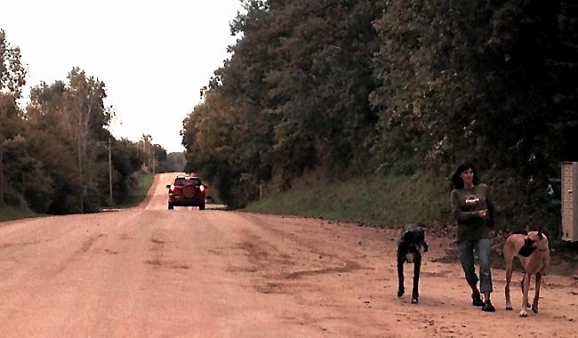

(I)dentify : 1. _________________________________________________________

2. _________________________________________________________

(P)redict : 1. _________________________________________________________

2. _________________________________________________________

(D)ecide : 1. _________________________________________________________

2. _________________________________________________________

(E)xecute : 1. _________________________________________________________

10. You are approaching the intersection fast and want to continue straight.

(I)dentify : 1. _________________________________________________________

2. _________________________________________________________

(P)redict : 1. _________________________________________________________

2. _________________________________________________________

(D)ecide : 1. _________________________________________________________

2. _________________________________________________________

(E)xecute : 1. _________________________________________________________

