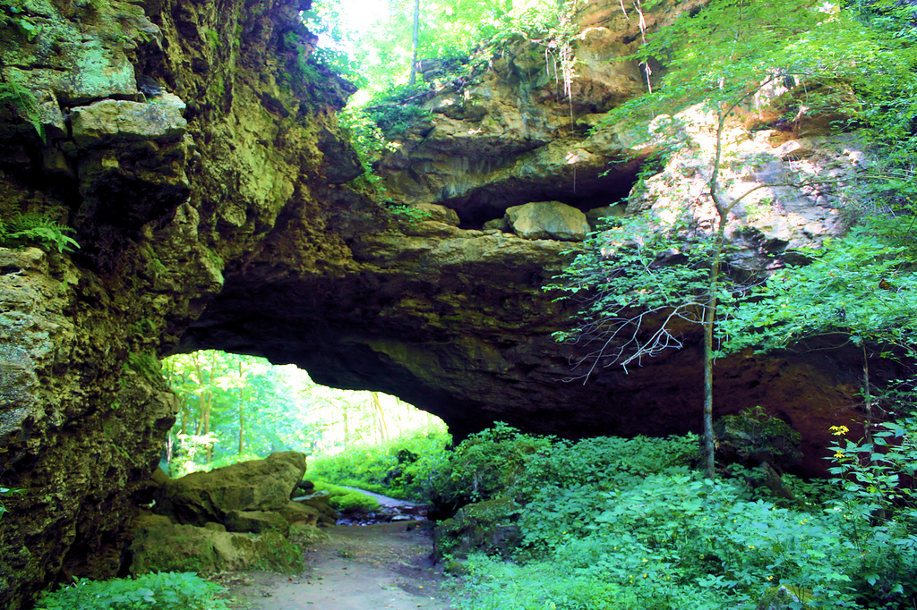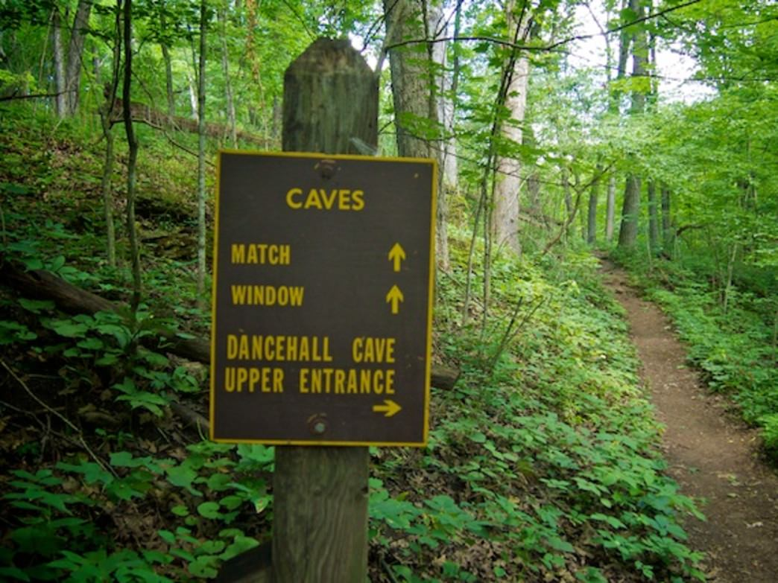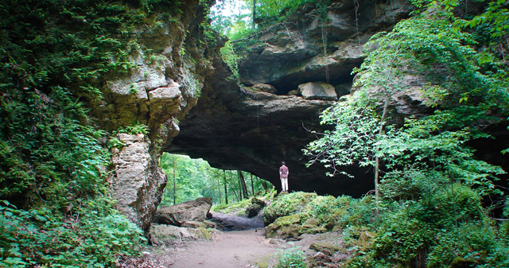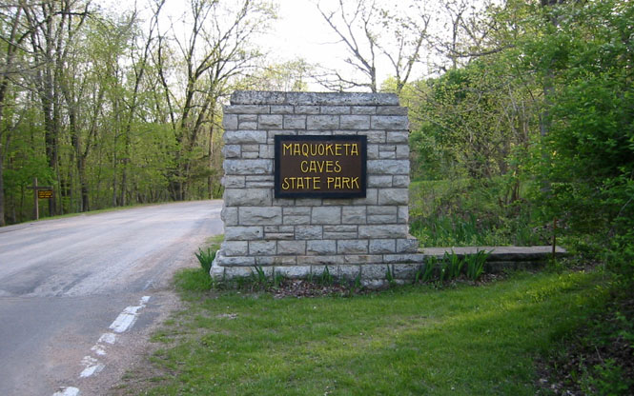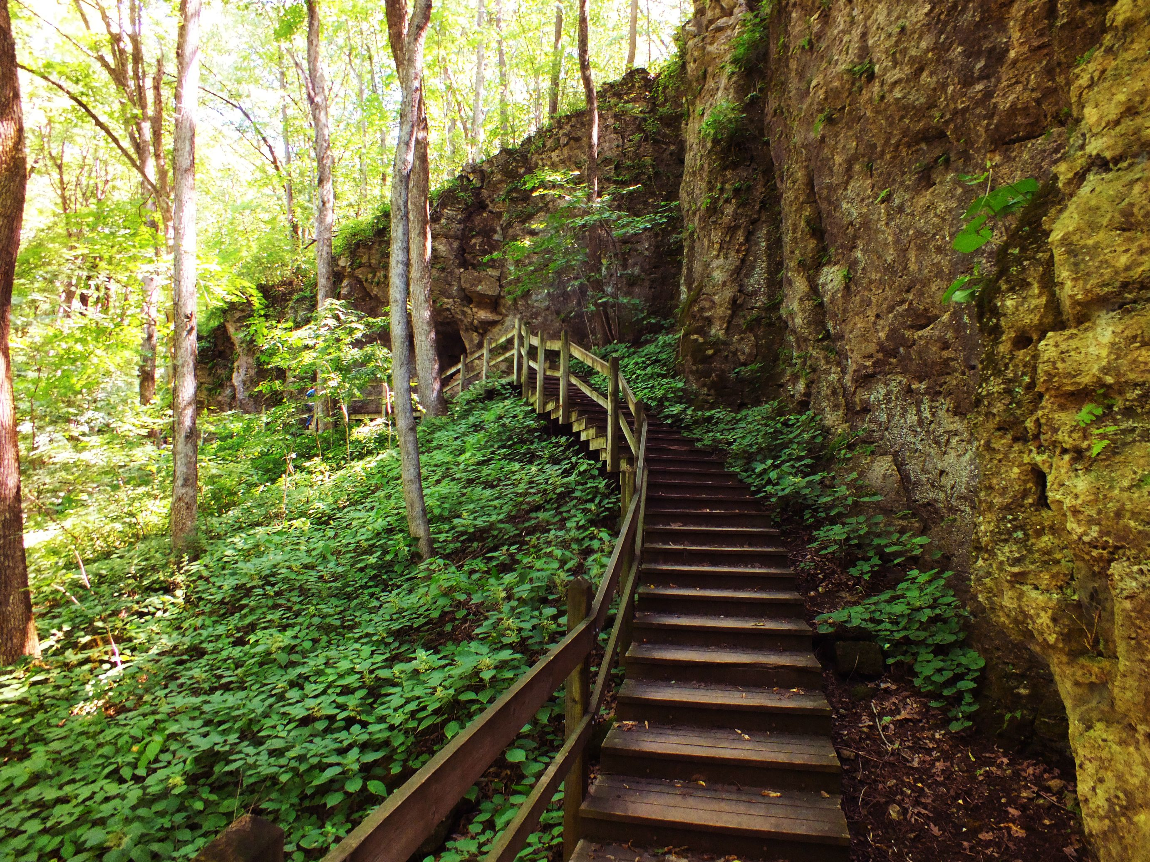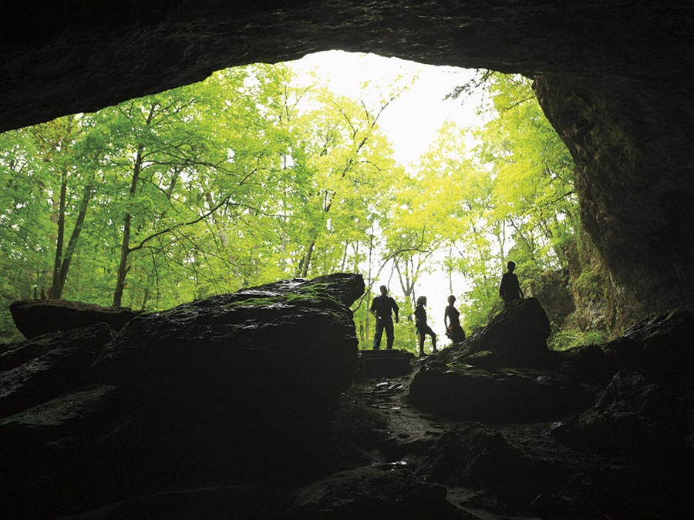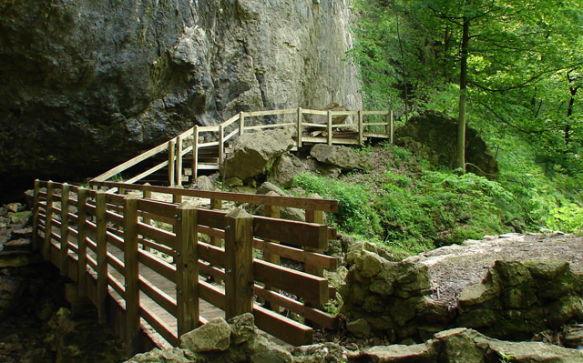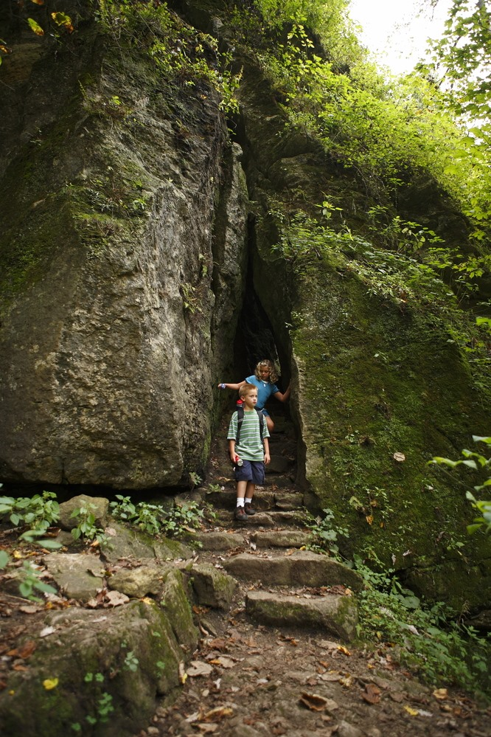

: Cave formation begun about 500,000 years ago

: Erosion exposed 430-million year old marine sea fossils

: Ancient artifacts (pottery, tools, & projectile points)

: Visited by Native-Americans in Raccoon Creek valleys

: 1st Euro-Americans arrived in mid-1830’s

: Popular place for picnics, parties & dances by the 1860’s

: Dance floor constructed in 1868 north of Natural Bridge

: Originally known as Morehead Caves State Park

: Park facilities created by CCC and WPA from 1932-1939

: 161 acres purchased as nature preserve from 1961-1981

**1.** Contains more caves than any other state park in Iowa

**2.** Souvenir hunters robbed the caves of stalactites & stalagmites

**3.** Caves closed from 2010-2012 due to bat white nose syndrome

**4.** Featured on *Rescue 911* in August 1988

**5.** Dancehall Cave is 800 ft. long with walkway & lighting

**6.** Balanced Rock along trail weighs 17-tons

**7.** Natural Bridge stands nearly 50 ft. above Raccoon Creek

**8.** First purchased by Iowa Federation of Women’s Club

**9.** Listed on National Register of Historic Places in 1991

**10.** Interpretive Center once called Sager’s Museum

**Craig Reuter**

Maquoketa

Caves State Park

# Maquoketa Caves

# History

# Maquoketa Caves

# Facts

🙞 🙜

: Water-carved caves from Silurian age dolomite bedrock

: Part of Driftless Area of Iowa (no glaciers from last ice age)

: Once had numerous stalactites and stalagmites

: 75-foot tall cliffs

: Raccoon Creek

: 150+ year Old Forest Growth

- White Oak

- Red Oak

- Sugar Maple

: Upland Second Growth

- Black Locust

- Elm

- Ash

: Cliff associated flora (ferns)

: Prairie preserve on west side

: 13 Caves (Spelunking, Hiking)

- Dancehall Cave

- Dugout Cave

- Hernando’s Hideaway

- Shinbone Cave

- Wye Cave

- Steelgate Cave

: Hiking (7 miles of trails)

- Natural Bridge

- Balanced Rock

: 29 Campsites (17 electric)

: Modern Shower Facility

: 2 Open Picnic Shelters

: Playground

: Interpretive Center

**Nearby City :**

Maquoketa, Iowa

**County :**

Jackson County

**Area :**

323 acres

**Date Established** **:**

1921

**Nearest Body Of Water :**

Raccoon River

# Maquoketa Caves Natural Resources

# Maquoketa Caves Recreation

# Maquoketa Caves

# Statistics