Star In A Box

I. Introduction

The Hertzsprung-Russell diagram (HR diagram) is one of the most important tools in the study of stellar evolution. Developed independently in the early 1900s by Ejnar Hertzsprung and Henry Norris Russell, it plots the temperature of stars against their luminosity, or the color of stars against their absolute magnitude.
Depending on its initial mass, every star goes through specific evolutionary stages dictated by its internal structure and how it produces energy. Each of these stages corresponds to a change in the temperature and luminosity of the star, which can be seen to move to different regions on the HR diagram as it evolves. This reveals the true power of the HR diagram – astronomers can know a star’s internal structure and evolutionary stage simply by determining its position in the diagram.

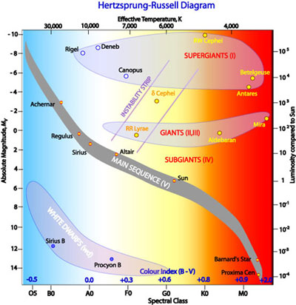

This Hertzsprung-Russell diagram shows a group of stars in various stages of their evolution. By far the most prominent feature is the main sequence, which runs from the upper left (hot, luminous stars) to the bottom right (cool, faint stars) of the diagram. The giant branch is also well populated and there are many white dwarfs.
Astronomers generally use the HR diagram to either summarize the evolution of stars, or to investigate the properties of a collection of stars. In particular, by plotting a HR diagram for either a globular or open cluster of stars, astronomers can estimate the age of the cluster from where stars appear to turn off the main sequence (see the entry on main sequence for how this works).

In this Virtual Lab, you will use theoretical models of stars of different masses to describe their development through time using radius, temperature, and luminosity changes.

II. Procedure

1. Start the activity by going to the following website :
https://starinabox.lco.global/ .
2. Launch Star in a Box and open the lid. The main plot is a Hertzsprung-Russell diagram. On the right, the information panel allows comparisons between the radius, surface temperature and luminosity of the star relative to the Sun. The starting parameters are for a star like the Sun.
3. ​From the drop-down menu, choose 1 solar mass star. Then, determine the mass, luminosity, radius, surface temperature, and lifespan of the star using the button on the side.
Click on the “Two Spheres” button and describe how the radius changes with time.
__________________________________________________________________
__________________________________________________________________
Click on the “Thermometer” button and describe how the radius changes with time.
__________________________________________________________________
__________________________________________________________________
Click on the “Light Bulb” button and describe how the luminosity changes with time.
__________________________________________________________________
__________________________________________________________________
Click on the “Clock” button and describe how the star changes with time?
__________________________________________________________________
__________________________________________________________________
What do you think happens to the rest of the mass?
__________________________________________________________________
__________________________________________________________________
Some of the changes in luminosity and temperature are very sudden. What do you think might be happening within the star at these changes?
__________________________________________________________________
__________________________________________________________________

4. From the drop-down menu, choose 30 solar mass star. Then, determine the mass, luminosity, radius, surface temperature, and lifespan of the star using the button on the side.
Click on the “Two Spheres” button and describe how the radius changes with time.
__________________________________________________________________
__________________________________________________________________
Click on the “Thermometer” button and describe how the radius changes with time.
__________________________________________________________________
__________________________________________________________________
Click on the “Light Bulb” button and describe how the luminosity changes with time.
__________________________________________________________________
__________________________________________________________________
Click on the “Clock” button and describe how the star changes with time?
__________________________________________________________________
__________________________________________________________________
How are the compositions of the two stars changing over their life times?
__________________________________________________________________
__________________________________________________________________
5. Betelguese is 20 times the mass of the Sun and very near the end of its life. It is 450 light years away, but how bright would it look compared with the Sun if it were at the distance of the Sun?
________________________________________________________________________
________________________________________________________________________
How large would it be compared with the orbit of the planets?
__________________________________________________________________
__________________________________________________________________

