Waves & Tsunamis

I. Introduction

A tsunami is a series of extremely long waves caused by a large and sudden displacement of the ocean, usually the result of an earthquake below or near the ocean floor. This force creates waves that radiate outward in all directions away from their source, sometimes crossing entire ocean basins. Unlike wind-driven waves, which only travel through the topmost layer of the ocean, tsunamis move through the entire water column, from the ocean floor to the ocean surface.
Most tsunamis are caused by earthquakes however tsunamis can also be caused by landslides, volcanic activity, certain types of weather, and—possibly—near-earth objects (e.g., asteroids, comets) colliding with or exploding above the ocean.
Once a tsunami forms, its speed depends on the depth of the ocean. In the deep ocean, a tsunami can move as fast as a jet plane, over 500 mph, and its wavelength, the distance from crest to crest, may be hundreds of miles. Mariners at sea will not normally notice a tsunami as it passes beneath them; in deep water, the top of the wave rarely reaches more than three feet higher than the ocean swell.
A tsunami only becomes hazardous when it approaches land. As a tsunami enters shallow water near coastal shorelines, it slows to 20 to 30 mph. The wavelength decreases, the height increases, and currents intensify. When they strike land, most tsunamis are less than 10 feet high, but in extreme cases, they can exceed 100 feet near their source. A tsunami may come onshore like a fast-rising flood or a wall of turbulent water, and a large tsunami can flood low-lying coastal areas more than a mile inland.

Rushing water from waves, floods, and rivers is incredibly powerful. Just six inches of fast-moving water can knock adults off their feet, and twelve inches can carry away a small car. Tsunamis can be particularly destructive because of their speed and volume. They are also dangerous as they return to the sea, carrying debris and people with them. The first wave in a tsunami may not be the last, the largest, or the most damaging. Stay out of the tsunami hazard zone until local officials tell you it is safe, as the danger may last for hours or days.

In this Virtual Lab you will use an understanding of water wave dynamics to better understand the nature of tsunamis generated earthquakes in the ocean.

II. Procedure

1. Watch the following 3-D Simulation of a tsunami.
https://www.youtube.com/watch?v=SlwZzbGh7Cw

2. Start the activity by going to the following website :
https://phet.colorado.edu/sims/html/waves-intro/latest/waves-intro_en.html .

3. IF NECESSARY, click on “Run Now!” and open the JNLP file. If not, just open the
simulator.

4. Click on the “Water” button. NOTE : This will illustrate the nature of water waves without
breaking on a shoreline.

5. Choose the “Side View” and “Slow” options and check the “Graph” option.

6. Drag the Stopwatch onto to the simulation screen.

7. Drag the Tape Measure to the dotted white line (water surface) and position the leftmost (+)
sign on the 0.5 cm mark. Then, click and drag the rightmost (+) sign on the tape measure
until the tape measure if measuring height (perpendicular to the wave direction).

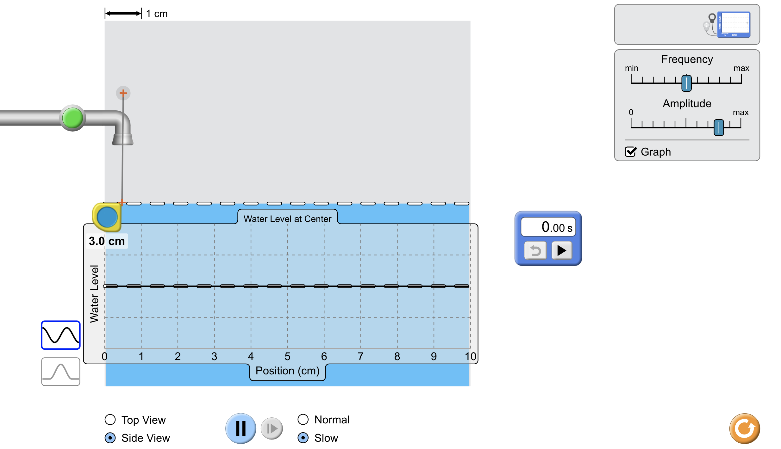

8. Click the green faucet button once and let the simulation run for about 10 seconds and click
“Pause”.

9. Measure the maximum Wave Height at 0.5 cm, 2.0 cm, 4.0 cm, 6.0 cm, 8.0 cm, and 10.0 cm.
Record the data in the Table. Un-pause the simulation and record the Time it takes for the
wave to leave the 0.5 cm mark and progress to the 10.0 cm mark (using the stopwatch).

10. Click the “Reset” button (bottom right) and repeat steps 5. – 8. but this time changing the
following conditions : (record your data in the Table)

1) Decrease the Frequency
2) Maximize the Frequency
3) Decrease the Amplitude
4) Maximize the Amplitude

III. Data

1. Record your data in the Table below.

 | Maximum Wave Height (cm) |  |  |  |  |  | Time  (sec.)
 | 0.5 cm | 2.0 cm | 4.0 cm | 6.0 cm | 8.0 cm | 10.0 cm
Initial
Trial
Decreased
Frequency
Maximum
Frequency
Decreased
Amplitude
Maximum
Amplitude

IV. Analysis & Conclusions

1. What conditions produced the following :

Tallest Wave Possible : ____________________________________________________

Longest Wave Possible : ___________________________________________________

Shortest Wave Possible : ___________________________________________________

Fastest Wave Possible : ____________________________________________________

Slowest Wave Possible : ___________________________________________________

2. How is this simulation similar to waves produced by tsunamis?

________________________________________________________________________

________________________________________________________________________

________________________________________________________________________

3. How is this simulation different to waves produced by tsunamis?

________________________________________________________________________

________________________________________________________________________

________________________________________________________________________

4. If you were out at sea and a tsunami was approaching, what would you do?

________________________________________________________________________

________________________________________________________________________

________________________________________________________________________

5. If you were near the shoreline and a tsunami was approaching, what would you do?

________________________________________________________________________

________________________________________________________________________

________________________________________________________________________

