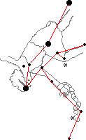 Andromeda

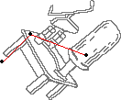 Antila

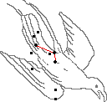 Apus

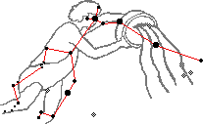 Aquarius

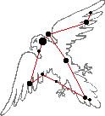 Aquila

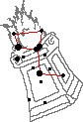 Ara

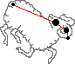 Aries

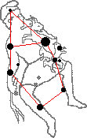 Auriga

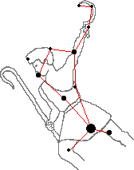 Bootes

http://coldwater.k12.mi.us/lms/planetarium/myth/Cae-myth.gif Caelum

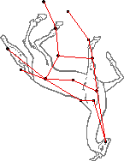 Camelopardalis

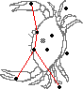 Cancer

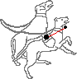 Canes Venatici

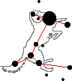 Canes Major

http://coldwater.k12.mi.us/lms/planetarium/myth/CMi-myth.gif Canes Minor

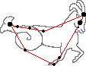 Capricornicus

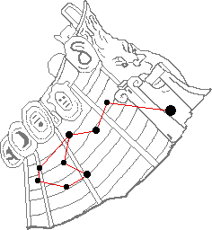 Carina

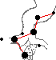 Cassiopeia

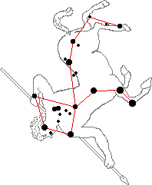 Centaurus

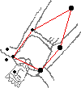 Cepheus

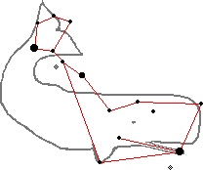 Cetus

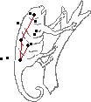 Chameleon

http://coldwater.k12.mi.us/lms/planetarium/myth/Cir-myth.gif Circinus

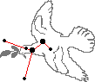 Columba

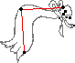 Coma Berenices

http://coldwater.k12.mi.us/lms/planetarium/myth/CrA-myth.gif Corona Australis

http://coldwater.k12.mi.us/lms/planetarium/myth/CrB-myth.gif Corona Borealis

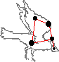 Corvus

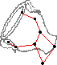 Crater

http://coldwater.k12.mi.us/lms/planetarium/myth/Cru-myth.gif Crux

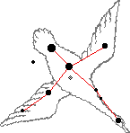 Cygnus

http://coldwater.k12.mi.us/lms/planetarium/myth/Del-myth.gif Delphinus

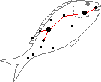 Dorado

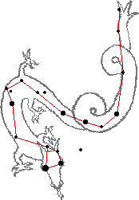 Draco

http://coldwater.k12.mi.us/lms/planetarium/myth/Equ-myth.gif Equuleus

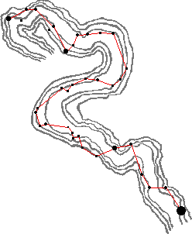 Eridanus

http://coldwater.k12.mi.us/lms/planetarium/myth/For-myth.gif Fornax

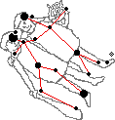 Gemini

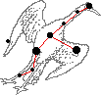 Grus

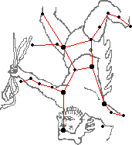 Hercules

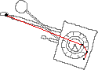 Horologium

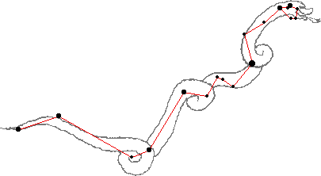 Hydra

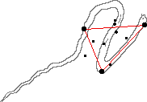 Hydrus

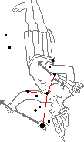 Indus

http://coldwater.k12.mi.us/lms/planetarium/myth/Lac-myth.gif Lacerta

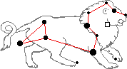 Leo

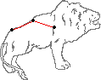 Leo Minor

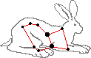 Lepus

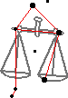 Libra

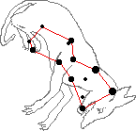Lupus

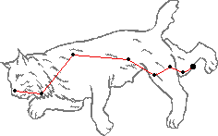 Lynx

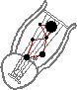 Lyra

http://coldwater.k12.mi.us/lms/planetarium/myth/Men-myth.gif Mensa

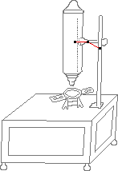 Microscopium

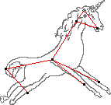 Monoceros

http://coldwater.k12.mi.us/lms/planetarium/myth/Mus-myth.gif Musca

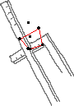 Norma

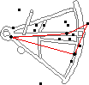 Octans

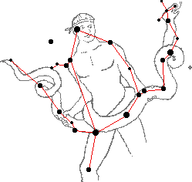 Ophiuchus

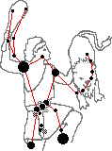 Orion

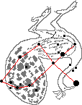 Pavo

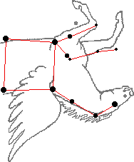 Pegasus

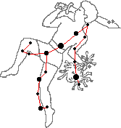 Perseus

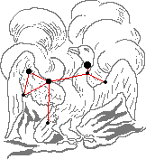 Phoenix

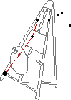 Pictor

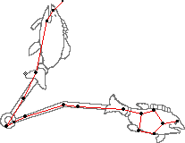 Pisces

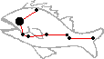 Pisces Austrinus

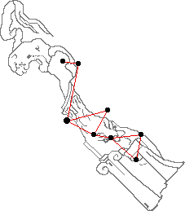 Puppis

http://coldwater.k12.mi.us/lms/planetarium/myth/Pyx-myth.gif Pyxis

http://coldwater.k12.mi.us/lms/planetarium/myth/Ret-myth.gif Reticulum

http://coldwater.k12.mi.us/lms/planetarium/myth/Sge-myth.gif Sagitta

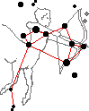 Sagittarius

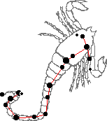 Scorpius

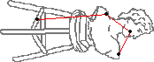 Sculptor

http://coldwater.k12.mi.us/lms/planetarium/myth/Sct-myth.gif Scutum

 Serpens

http://coldwater.k12.mi.us/lms/planetarium/myth/Sex-myth.gif Sextans

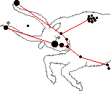 Taurus

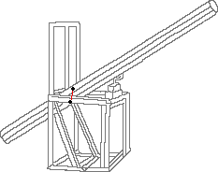 Telescopium

http://coldwater.k12.mi.us/lms/planetarium/myth/Tri-myth.gif Triangulum

http://coldwater.k12.mi.us/lms/planetarium/myth/TrA-myth.gif Triangulum Australe

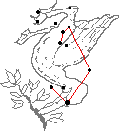 Tucana

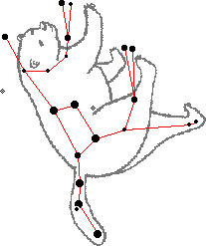 Ursa Major

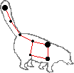 Ursa Minor

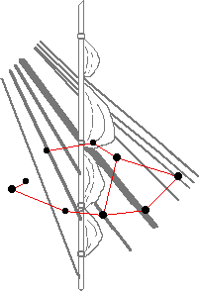 Vela

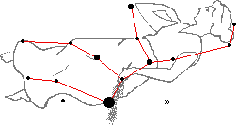 Virgo

http://coldwater.k12.mi.us/lms/planetarium/myth/Vol-myth.gif Volan

http://coldwater.k12.mi.us/lms/planetarium/myth/Vul-myth.gif Vulpecula