Pedigree / DNA Model Project

DNA is made up of molecules called nucleotides. Each nucleotide contains a phosphate group, a sugar group and a nitrogen base. The four types of nitrogen bases are adenine (A), thymine (T), guanine (G) and cytosine (C). The order of these bases is what determines DNA's instructions, or genetic code. Human DNA has around 3 billion bases, and more than 99 percent of those bases are the same in all people.

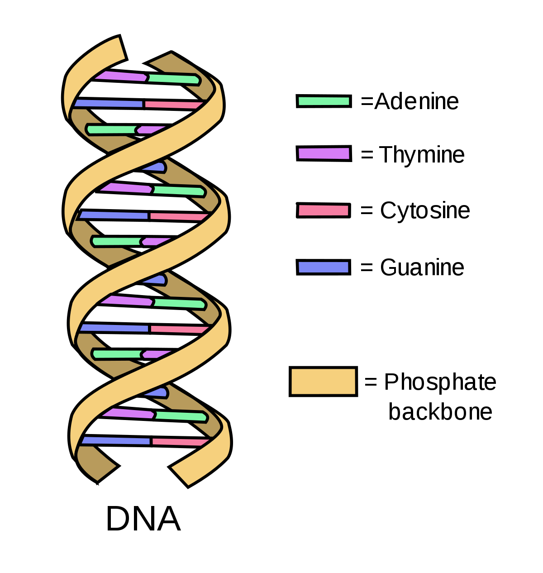

Pedigrees are used to analyze the pattern of inheritance of a particular trait throughout a family. Pedigrees show the presence or absence of a trait as it relates to the relationship among parents, offspring, and siblings. Pedigrees represent family members and relationships using standardized symbols. By analyzing a pedigree, we can determine genotypes, identify
phenotypes, and predict how a trait will be passed on in the future. The information from a pedigree makes it possible to determine how certain alleles are inherited: whether they are
dominant, recessive, autosomal, or sex-linked.

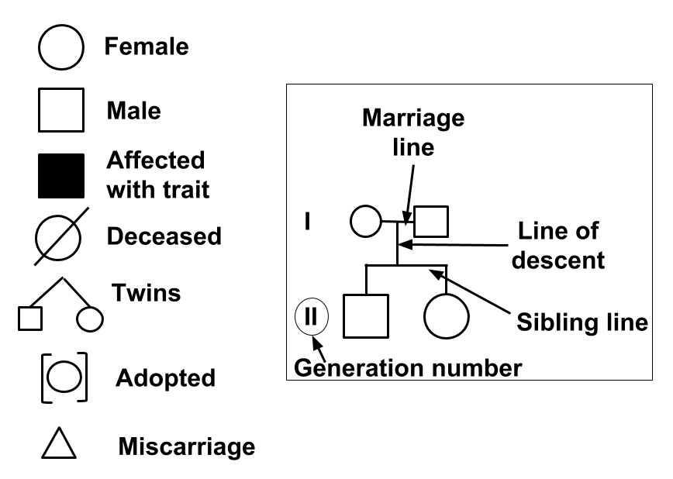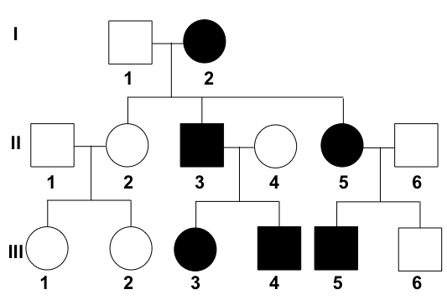

For this project, you will be given the option to construct a multi-generational pedigree of a family trait or a DNA model. Ideally, pedigrees should be made in order to understand inheritance better, but the DNA model is an option if you cannot trace a trait throughout your family (adopted, divorced with no contact, limited surviving family, etc.). The following criteria is listed on the back side.

Pedigree

1. Determine a dominant trait to collect information from family members.
(Brown Eye Color, Dimples, Freckles, Curly Hair, Widow’s Peak, Detached
Earlobes, Right-Handedness, Roll Tongue, Webbed Fingers)

2. Collect enough information to make a 3-generation (minimum) pedigree.

3. Create a pedigree using squares for males, circles for females, horizontal lines
connecting parents or siblings, and vertical lines connecting generations.

4. Color code the pedigree with the filled-in, dark shapes possessing the recessive forms
of the trait.

5. Label names of each person, generations (Roman Numerals), and include a title.
(NO LINED PAPER!)

DNA Model

1. Create a DNA model out of art supplies or common household materials.

2. Color code the DNA model bases (A=T; C=G) and sugar phosphate backbone
(deoxyribose; phosphoric acid).

3. Create labels for adenine, cytosine, guanine, thymine, deoxyribose, phosphoric acid.

4. Be sure the DNA model is double-helical in shape.

5. The model should be able to be hung up from the ceiling with fishing line.

GRADING RUBRIC

PEDIGREE
EX = Exceeding MT = Meeting DV = Developing BG = Beginning

- Typed / Computer Generated - Nicely Written - Handwritten - Sloppy
- Dominant Trait Present - Dominant Trait Present - Random Trait Used - Random Trait Used
- 3 Generations Present - 3 Generations Present - 3 Generations Present - 2 Generations Present
- Proper Use of Male/Female - Proper Use of Male/Female - Proper Use of Male/Female - Male/Female Switched
- Proper Use of Lines - Proper Use of Lines - Proper Use of Lines - Proper Use of Lines
- Proper Color Coding - Proper Color Coding - Incorrect Color Coding - Incorrect Color Coding
- Labels / Title Included - Labels / Title Included - Labels or Title Missing - Labels & Title Missing
- Neat & Organized - Neat & Organized - Disorganized - Messy & Disorganized
- Missing 1 Element

DNA MODEL
EX = Exceeding MT = Meeting DV = Developing BG = Beginning

- Labels Present & Accurate - Labels Present & Accurate - Labels Present (Not Accurate) - No Labels
- Model Color-Coded - Model Color-Coded - Incomplete Color-Coding - Not Color-Coded
- Double-Helical Shape - Double-Helical Shape - Double-Helical Shape - Not Double-Helical
- Able To Be Hung Up - Able To Be Hung Up - Able To Be Hung Up - Not Able To Hang Up
- Well-Constructed Model - Well Constructed Model - Flimsy Construction - Flimsy Construction
- Creative Use Of Materials - Creative Use Of Materials - Creative Use Of Materials - Model “Thrown Together”
- Intricate Detail
- Above & Beyond Effort

