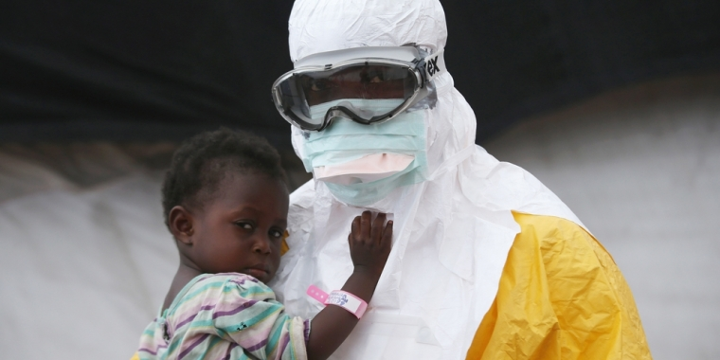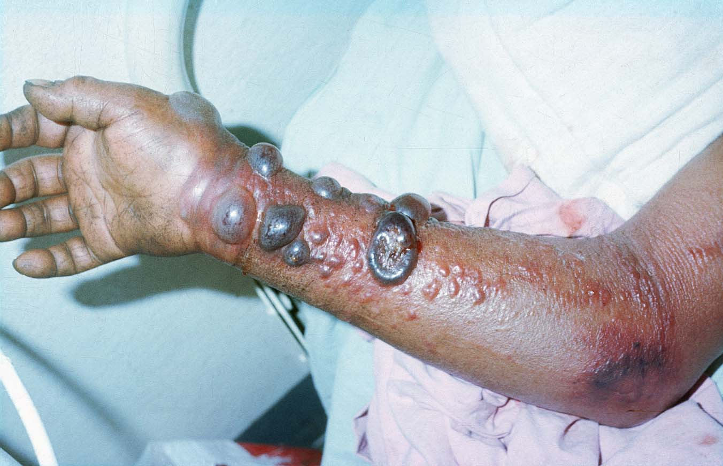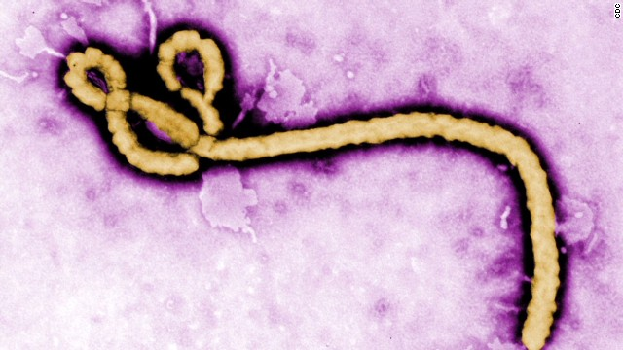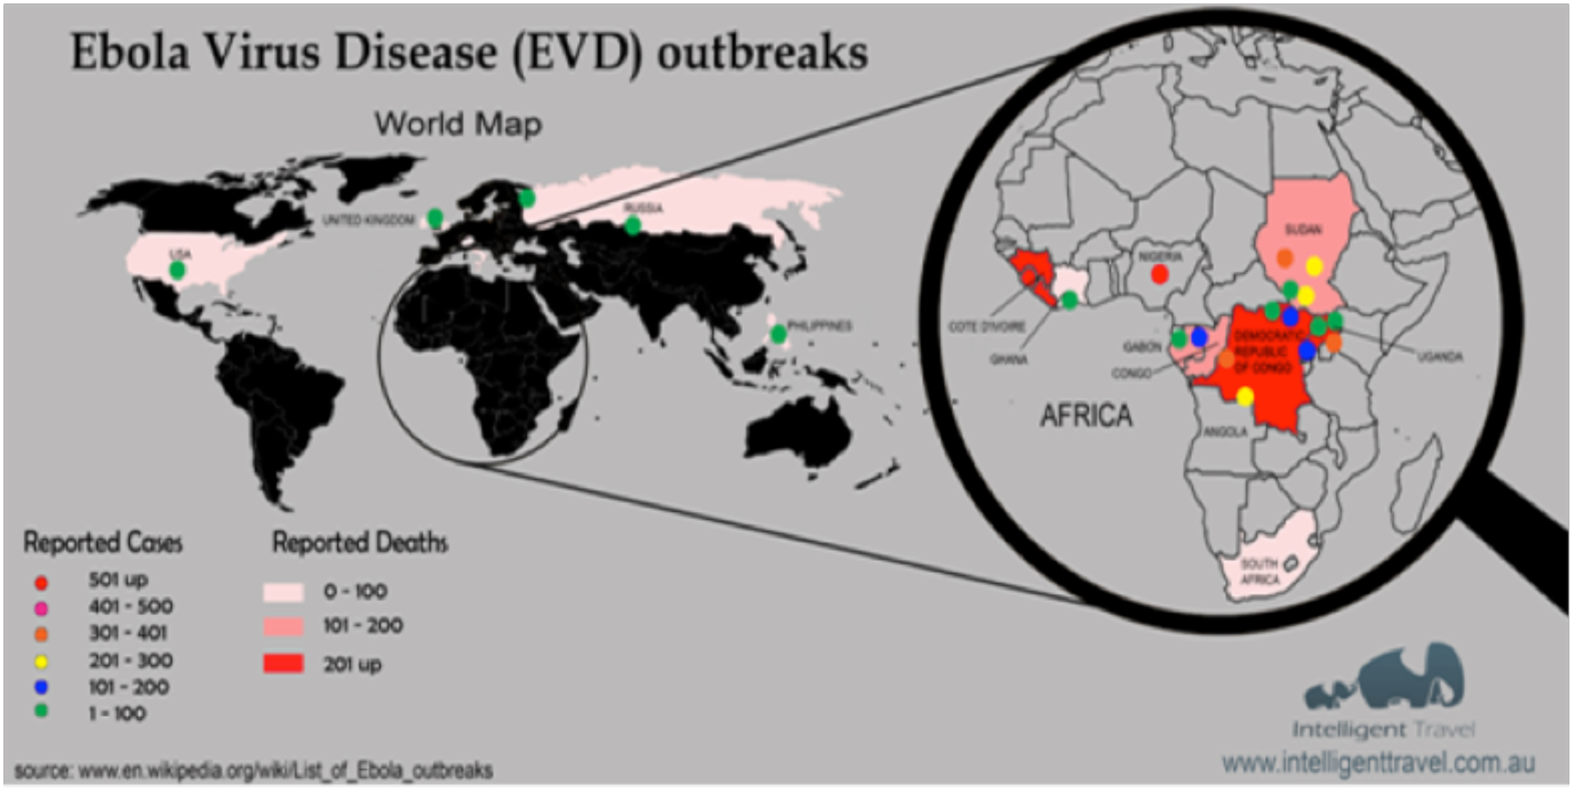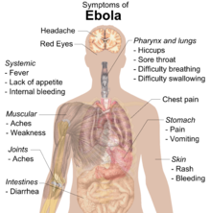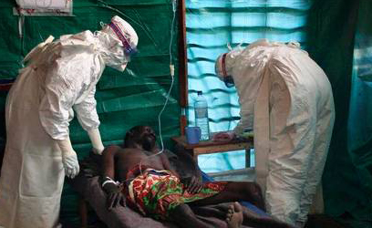

**Organization #1**

**Address Line 1**

**Address Line 2**

**Phone Number**

[**Email**](http://www.cdc.gov) **site**

**Organization #1**

**Address Line 1**

**Address Line 2**

**Phone Number**

[**Email**](http://www.cdc.gov) **site**

**Organization #1**

**Address Line 1**

**Address Line 2**

**Phone Number**

[**Email**](http://www.cdc.gov) **site**

**Organization #1**

**Address Line 1**

**Address Line 2**

**Phone Number**

[**Email**](http://www.cdc.gov) **site**

**Organization #1**

**Address Line 1**

**Address Line 2**

**Phone Number**

[**Email**](http://www.cdc.gov) **site**

* First discovered in 1976 in Central Africa
* Named after Ebola River (Congo)
* Fatality rate over 45 is 94%
* Fatality rate under 21 is 57%
* 1976 - 2014 : 25 Outbreaks (with about 1,500 deaths)
* 2014 - 2016 : 2 Outbreaks (with about 11,374 deaths)
* 2014 Outbreak started in Guinea, Liberia, & Sierra Leone
* Head doctor of the 2014 Outbreak died from the disease
* Four people have had Ebola in the United States
* Ebola is a type of RNA virus

Ebola Virus

# Extra Facts

# Help Section

Craig Reuter

### Biology

### 5th Block

### 2/10/2017

🙞 🙜

* Diagnosis
  + Blood Tests
  + ELISA Test
  + IgM ELISA Test
  + PCR Test
  + IgC Antibodies Test
* Treatment
  + No specific treatment found yet
  + Provide fluids
  + Replace lost blood
  + Immune therapy
  + Provide oxygen
  + Experimental vaccines
  + Pain medication

(For inevitable death)

* Caused by the *Zaire ebolavirus*
* Transmitted by direct contact with blood, body fluids, or skin
* Having direct contact through the eyes, nose, or mouth
* Needles & syringes contaminated with the virus
* Become infected when in contact of infected animal
* Cannot spread through water, air, or by food
* Can be spread in healthcare center if staff are not wearing appropriate protective gear
* Very severe in humans (Africa)
* Once people recover they can no longer spread the virus
* Has been detected in semen after patients have recovered
* Symptoms may appear 2-21 days
* **Symptoms**
  + Unexplained Bleeding
  + Excessive Bruising
  + Bloody Diarrhea
  + Fever
  + Severe Headache
  + Vomiting
  + Joint & Muscle Pain
  + Severe Weight Loss
  + Chills
  + Sore Throat
  + Stomach Pain
  + Reddened Eyes

# Treatment & Diagnosis

# Symptoms

# Transmission & Prevalence