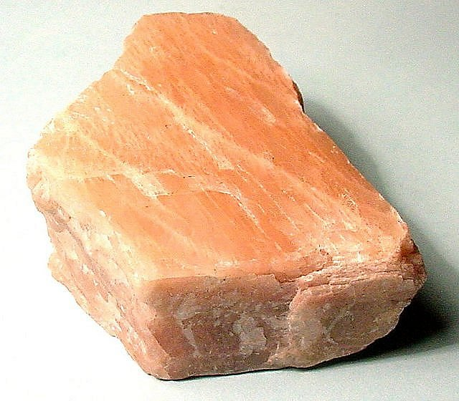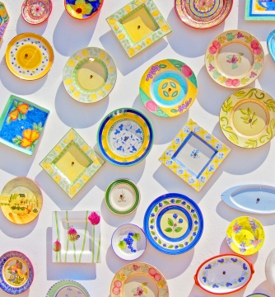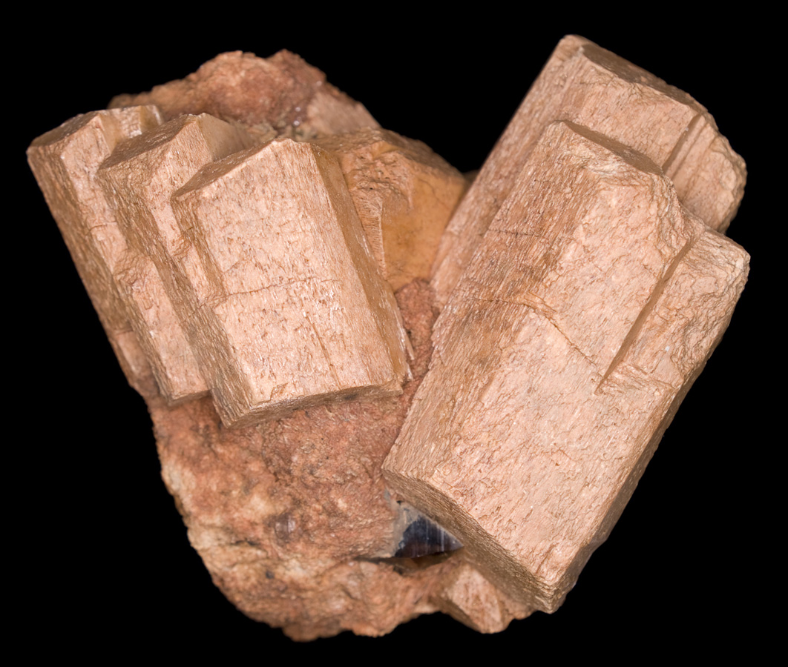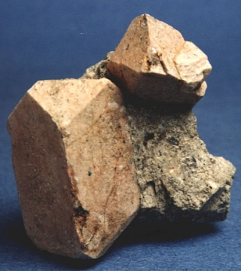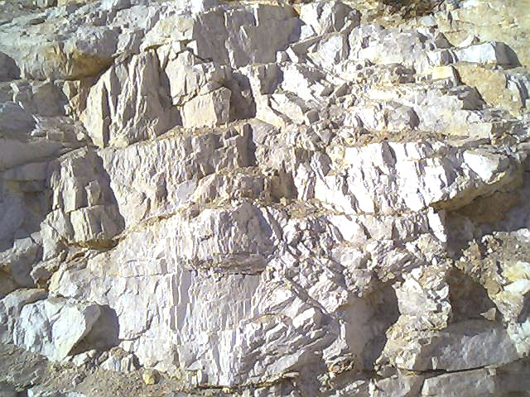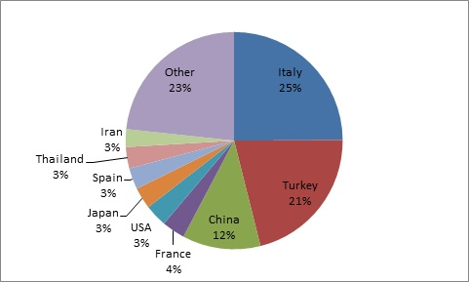

**1.** Feldspar is the most common mineral on Earth

**2.** Feldspar consists of 60% of the Earth’s crust

**3.** Feldspar is a major component of granite

**4.** The term feldspar is derived from the German “feldt spat”

**5.** Commercial feldspar is known as Orthoclase

**6.** Feldspar is mined in almost every country

**7.** Types of feldspar include : Orthoclase, Microcline, & Plagioclase

**8.** Feldspar is a component of porcelain and china.

**9.** The more calcium in feldspar, the darker the mineral.

**10.** The more sodium in feldspar, the lighter the mineral.

**Glass-Making**

- Glass Containers

- Glass Fibers

**Ceramics**

- Flux (Bonding Agent)

- Electrical Insulators

- Sanitaryware

- Pottery

- Tableware

- Tile

**Filler**

- Paints

- Plastics

- Rubber

Feldspar

# Commercial Uses

# Feldspar Facts

Craig Reuter

### General Science

### 1st Block

### 12/4/2015

🙞 🙜

**Italy (#1 Producer)**

**Turkey**

**China**

**Thailand**

**United States**

- North Carolina

- Virginia

- California

- Oklahoma

- Idaho

- Georgia

- South Dakota

**Crystal Form**

– Triclinic or

Monoclinic

**Chemical Composition**

– KAlSi3O8,

NaAlSi3O8,

or CaAl2Si2O8

**Specific Gravity** – 2.55 – 2.76

**Tenacity** – Brittle

**Transparency** – Opaque

**Appearance**

– Pink, White, Gray,

or Brown

**Hardness** – 6.0 – 6.5

**Luster** – Vitreous

**Streak** – White

**Cleavage** – 2 or 3 Planes

**Fracture** – Conchoidal to Uneven

# Feldspar Locations

# Physical Properties

# Feldspar Characteristics