Hurdling iMovie

Mr. Craig L. Reuter

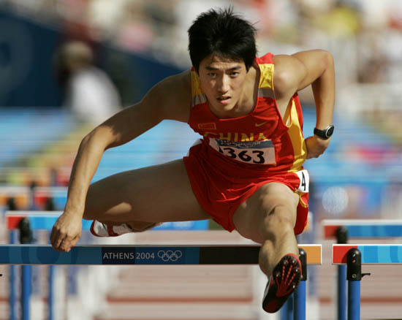General Science
3rd Period

2/13/14
Hurdling

A. History

- Technique
Evolved from tuck jumps to low-line sprints
- Barriers
Initially heavy wooden structures embedded into ground
1895 : T-shaped frame
1935 : L-shaped frame (tips over)
- Distances
Originally a 100-yard race
1864 : 120-yard distance
1898 : 110-meter high hurdles (Women : 100-meter hurdles)
- Olympics
1st appeared in 1896
1928 : Women’s event included
- Records
12.21 seconds (1986) : Yordanka Donkova (Bulgaria)
12.87 seconds (2008) : Dayron Robles (Cuba)

B. Technical Aspect #1

- Technique : Stepping
- Principle Applied : Velocity & Acceleration
- 8 Steps to the 1st Hurdle
Need quick acceleration
Avoid 10 individual races (Establish rhythm)
- Between Hurdles
3 Steps (Boys); 3 – 4 Steps (Girls)
- Less steps = Less time to cover distance
3 vs. 4 Steps = 40 less steps

C. Technical Aspect #2

- Technique : Take-Off
- Principle Applied : Projectile Angle
- Take –off 1 – 1 ½ meters away from hurdle
Running Vs. Jumping
- ATTACK with a low angle
Limits hang time of trajectory
Can’t run in the air
- Lean into the hurdle
Limits air resistance
Lowers center of mass (less disruptions)
Contributes to linear momentum

D. Technical Aspect #3

- Technique : Leg Action
- Principle Applied : Rotational Dynamics
- Lead Leg – “Up, Out, Down”
Avoid swinging leg up
Disrupts center of mass
Adds rotational dimension
- Trail Leg – “Pull through fast”
3 points of flexion
Avoid “clipping” hurdle
Contributes to linear momentum
- “Snap” lead leg
Limits hang time of trajectory
Can’t run in the air

E. Technical Aspect #4

- Technique : Arm Motion
- Principle Applied : Rotational Inertia
- Avoid “Helicoptering”
Leads to Conservation of Momentum
Disrupts landings
- Avoid increasing Angular Velocity
Maintain linear velocity & acceleration
- Avoid crossing mid-line of body
Throws off center of mass

F. Recommendations

- Win the 3 parts of the race
1. Accelerate in 8 steps to 1st hurdle
2. Maintain 3 stepping through the middle
3. Slingshot over the last hurdle to the finish line
- Take off away from the hurdle
- Limit hang time trajectory
- Keep arms under control
- Think linear momentum, not angular momentum

