Intersection Scenarios

Describe how you would respond in each of the following intersection scenarios?

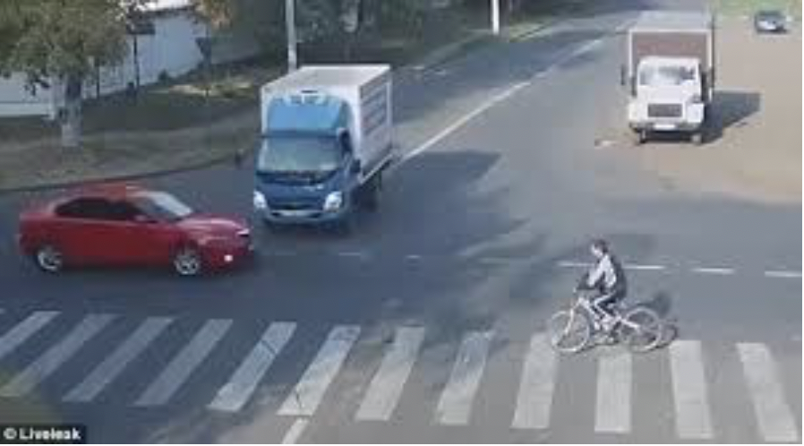

1. You are driving through an uncontrolled intersection and a box truck is approaching fast from the left side (which is supposed to be yielding). A kid is approaching while riding his bike to your right. What do you do?

______________________________________________________________________________

______________________________________________________________________________

______________________________________________________________________________

______________________________________________________________________________

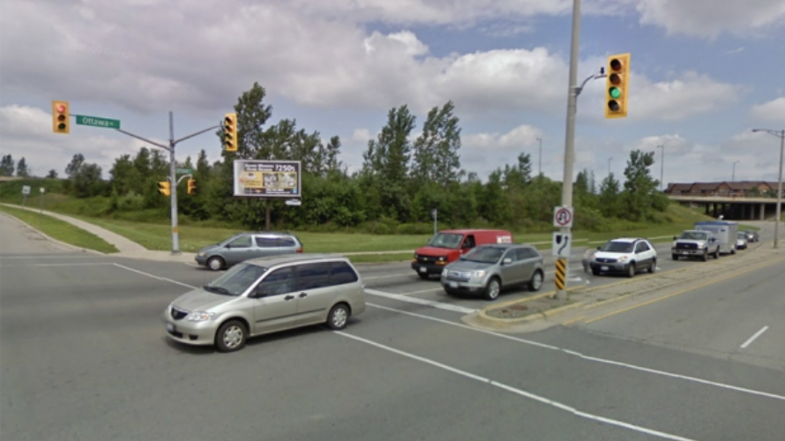

2. The red stop light turns green and you slowly accelerate. Halfway through the intersection, your van starts to stall. The van comes to a complete stop in the middle of the intersection. What do you do?

______________________________________________________________________________

______________________________________________________________________________

______________________________________________________________________________

______________________________________________________________________________
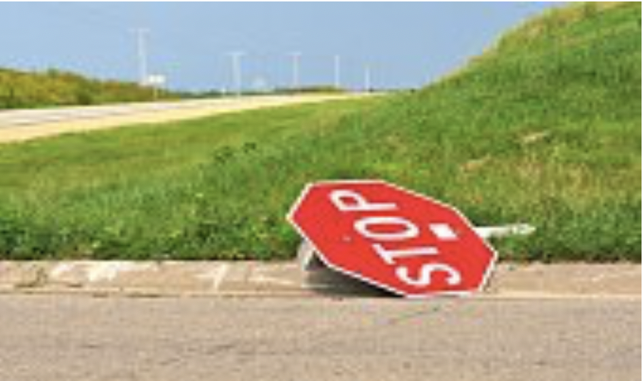

3. You approach a 4-way stop on a country road and notice a stop sign that is usually upright has been knocked over and lying on the ground. All three other signs are still up, and no one is approaching from any direction. What do you do?

______________________________________________________________________________

______________________________________________________________________________

______________________________________________________________________________

______________________________________________________________________________

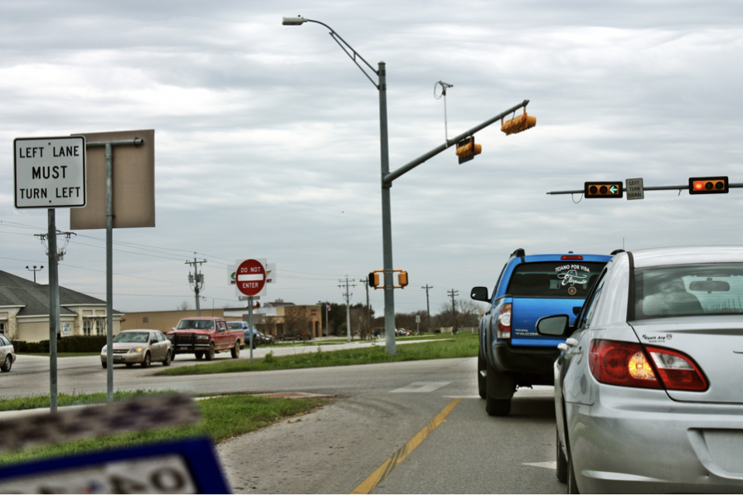

4. You are in a city with 4-lanes of traffic. While waiting in a turning lane at a stop light (to turn left), the light turns to a green arrow but the oncoming traffic does not stop. You have also already waited in line through one series of traffic light signals. What do you do?

______________________________________________________________________________

______________________________________________________________________________

______________________________________________________________________________

______________________________________________________________________________

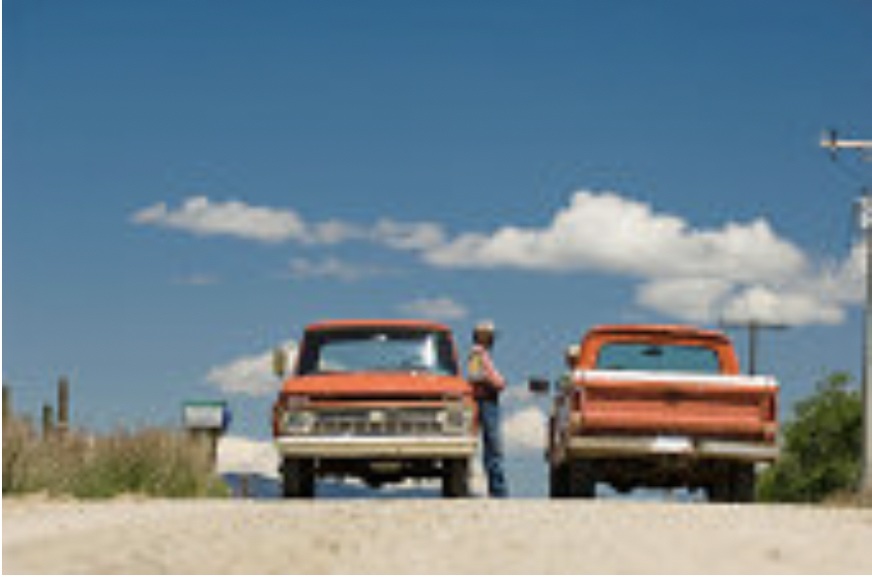

5. You approach a 4-way intersection and come upon one truck pulled over next to another truck parked by the stop sign. The two men in the trucks are carrying on a conversation and show no signs of moving. No one is waiting at the other stop signs. What do you do?

______________________________________________________________________________

______________________________________________________________________________

______________________________________________________________________________

______________________________________________________________________________

