My Solar System

I. Introduction

The Solar System is full many objects that are bound by the universal force of gravity. The balance that exists with gravity is based on object masses and distances between objects. If an objects mass increases, the gravitational pull of the object increases. If the distance between two objects increases, then the gravitational pull is weakened. Any change in the gravitational balance of the Solar System can produce drastic, devastating effects.

In this activity, you will examine the gravitational relationships between the Sun and Earth, Sun, Earth, & Moon, Comets, and Binary Stars.

II. Procedure

1. Go to the following website :
https://phet.colorado.edu/en/simulation/legacy/my-solar-system .

2. Choose the application labeled My Solar System.

3. Click on “Run Now!”. Then open the JNLP file.

4. Click the “Show Grid” box on the right of the screen. Drag the slider from “Fast” all the way
over to “Accurate”. At the bottom, select “3” for the number of bodies. Then fill out the
data table to look like this:

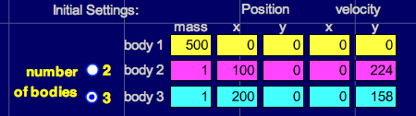

5. Click on “Start” and observe the motion, then answer the questions below.

Which planet (inner or outer) travels the least distance to go around once?

_____________________________________

Which planet is going the fastest?

_____________________________________

Which planet has the shortest ”year”?

_____________________________________

About how many times does the inner planet go around while the outer planet goes
around once?

_____________________________________

In our solar system, what is the name of the planet that goes the fastest? The slowest?

__________________________________________________________________

6. Click “Stop”, then click on the arrow next to “Select Preset” in the upper right of the screen,
then scroll down and select “Ellipses”. Click “Start” and answer the following questions
about the outer GREEN orbit relative to the yellow “Sun”.

Where in its orbit is the planet going the fastest? Slowest?

__________________________________________________________________

Where do you think gravity is the strongest? Weakest?

__________________________________________________________________

Comets have orbits similar to this one. Where would you expect a comet to spend most
of its time, near the Sun or far from the Sun? Why?

__________________________________________________________________

__________________________________________________________________

7. Click on the “2” by the number of bodies and fill in the data table to look like this:

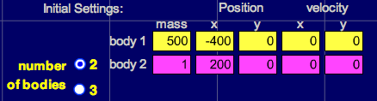

8. Notice the time output in the lower right of the screen. Click on “Start” and watch the small
mass fall toward the large mass. Measure the time it takes to hit by clicking on “Stop” as
soon as the small mass hits (the large mass will flash when they hit). Repeat the simulation
by clicking on “Reset” until you are sure you have an accurate time. Record your time for the
three trials below.

1. _______________ 2. _______________ 3. _______________

Predict what will happen to the time it takes the small planet to fall into the large planet if
we double the mass of the small planet. Write your prediction here.

__________________________________________________________________

9. Change the mass of Body 2 from 1 to 2. Click “Start” and measure the time it takes to hit.
Record it below. Was your prediction correct?

________________________________________________________________________

Predict the time it will take for body 2 to hit the star if we change its mass from 2 to 3.
Write your prediction here.

________________________________________________________________________

10. Change the mass of Body 2 from 2 to 3. Click “Start” and measure the time it takes to hit.
Record it in the table below. Was your prediction correct?

_______________________

Planet Mass | Time  Trial 1 | Time  Trial 2 | Time  Trial 3
1
2
3

Based on your results, should more massive objects fall to Earth faster than less massive
objects? Why or why not?

__________________________________________________________________

11. Click “Reset” then de-select the “System Centered” check box on the right of the screen.
Fill in the data table to look like this:

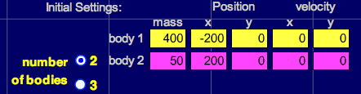

This creates one big planet and one small planet. Predict which planet will move the
most and what will happen after they collide below.

Click “Reset” then click “Start” and observe. Was your prediction correct? What do
they do after they collide?

__________________________________________________________________

Click “Reset” then change the 50 mass planet to 400 so they are equal. Predict what will
happen below.

__________________________________________________________________

Now click “Start” and observe. Was your prediction correct? What do they do after they
collide?

__________________________________________________________________

Click “Reset” then change the x velocity of planet 1 (yellow) to 100. Predict what will
happen after they collide.

__________________________________________________________________

Click “Start” and observe. Was your prediction correct? What do they do after they collide?

__________________________________________________________________

12. Go back to the “Presets” menu in the upper right of the screen and select “Four Star Ballet”
and run it. Look at a few others if you wish, then make up your own pattern by changing the
masses, x and y positions, and x and y velocities.

